Collision lab Practical: Testing your model !!!

Practice problem using data, graph, motion map, and equations
Two toy cars start 10 m apart, headed towards each other. The red car moves at 1.2 m/s, and the blue car has a speed of 0.8 m/s. Determine the location where they will collide.
We will start the red / blue (circle one) car at 0 m, and the red / blue (circle one) car at 10 m.
Fill in the Data table | Plot a graph of your motion
Time (s) Red car position (m) Blue car position (m)  Collision position & time: | 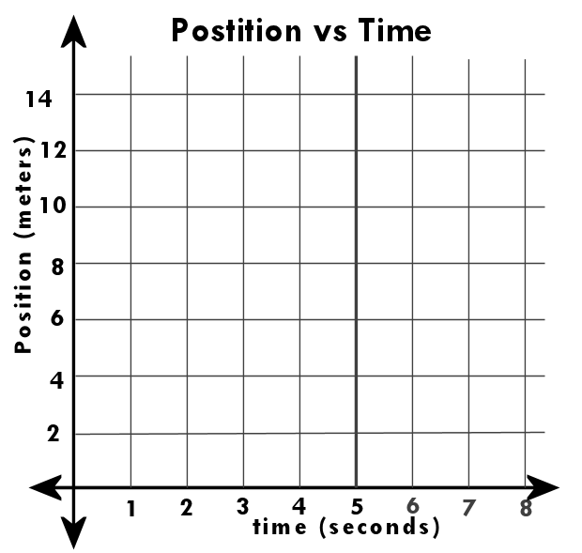  Collision position & time:

Draw a mOTION MAP of your motion
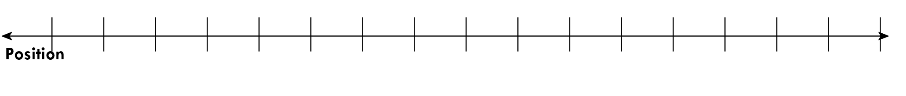
Collision position & time:

Solve using Two equations and two unknows
Red car equation:
Blue car equation:
Combine equations, rearrange, and solve for the collision location and time.

Calculated collision position & time:

Predict the collision Position and time for real toy cars
Your two cars start 4 m apart and are headed towards each other. Record you measured velocities here: The red car has a velocity of _______ m/s, and the blue car has a velocity of _______ m/s.
We will start the red / blue (circle one) car at 0 m, and the red / blue (circle one) car at 4.0 m.
Fill in the Data table | Plot a graph of your motion
Time (s) Red car position (m) Blue car position (m)  Collision position & time: | 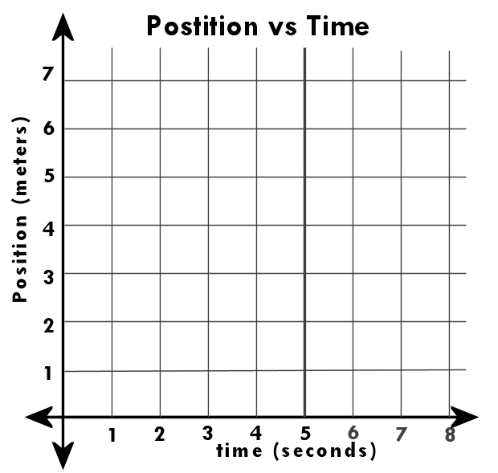  Collision position & time:

Draw a mOTION MAP of your motion
Collision position & time:

Solve using Two equations and two unknows
Red car equation:
Blue car equation:
Combine equations, rearrange, and solve for the collision location and time.
Calculated collision position & time:

